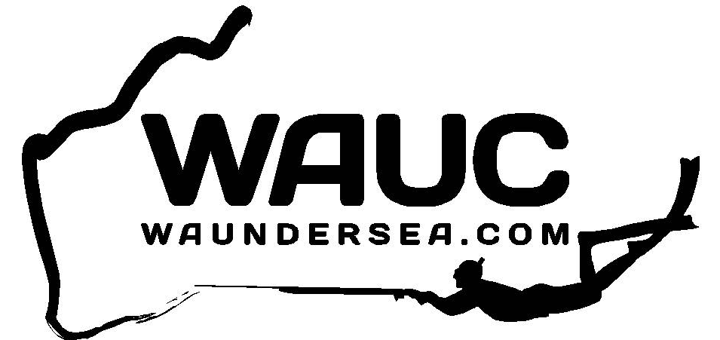

SpearWest Metro Spearfishing Competition 2017

- The competition will be on Sunday, March 12th 2017.
- Entry is free and open to all financial members of the West Australian Undersea Club Inc.
- All competing pairs must register by sending an SMS to Phil Carson 0409 399 128.
- The SMS must include names of both divers and be received by 5am on the day of the competition or a sms the day before the competition is fine.
- Start: Any time after sun up.
- Finish: 2:00pm at Charonia Park, Charonia Road - Mullalloo.
- Each pair must have signed off by the notified finish time
- Weigh-in commences at 2.30pm
- It is a freedive only competition
- Each diver to tow a float with flag.
- Competitors must be immersed in the water at time of spearing the fish.
- One fish of each species to be submitted per pair.
- Burleying is only permitted using fish speared on the day.
- Prizes awarded for 1st, 2nd and 3rd 4th and 5th pairs, most meritorious and mystery weight fish (open only to those who haven’t won a prize).
- Spearfishing organizer has final say on prize allocation.
- Should the day be cancelled, the competition will be postponed to the following day/weekend
- It is everyone’s responsibility to be aware of marine sanctuary boundaries. Anyone diving in a sanctuary will be disqualified.
- All fish to be submitted gutted and gilled and divers should ensure that fish are thoroughly cleaned. If, however you believe you may have a record fish, certified club scales will be available at the sign off area prior to gutting and gilling.
- Boat skippers are permitted.

Any questions, call Graham Gould 0412 945 722 or Aleks Ceklic 0413 906 665.

